1. Meeting Request from Barclays

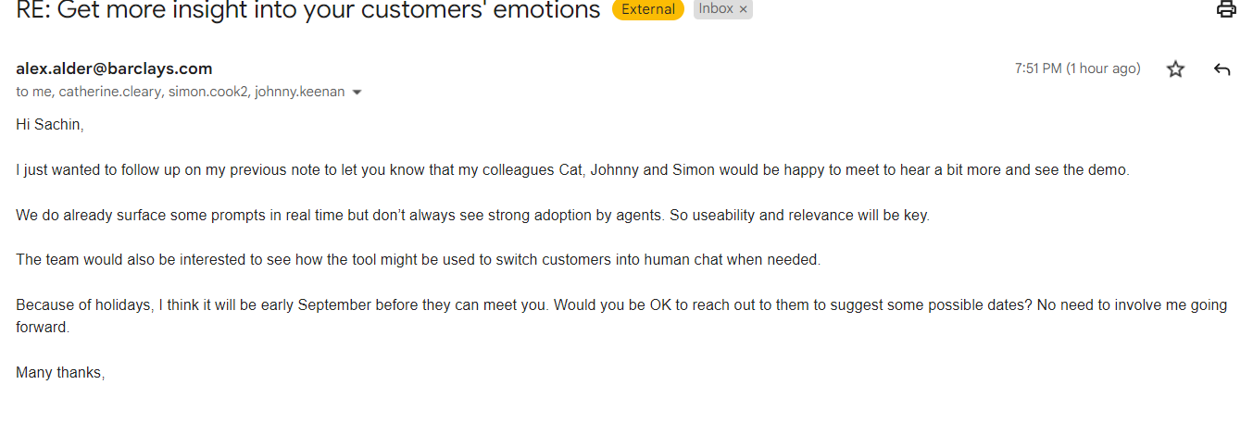

1. C&A

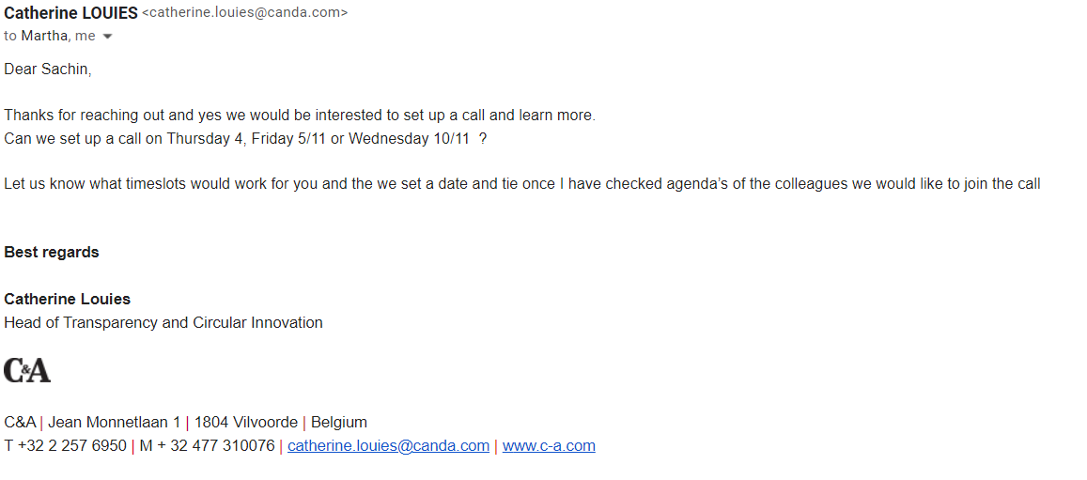

1. From CIO’s Office

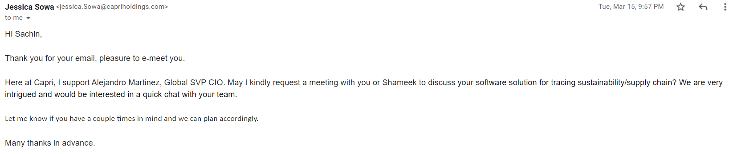

1. Lou Gizzerali – President of Quadient

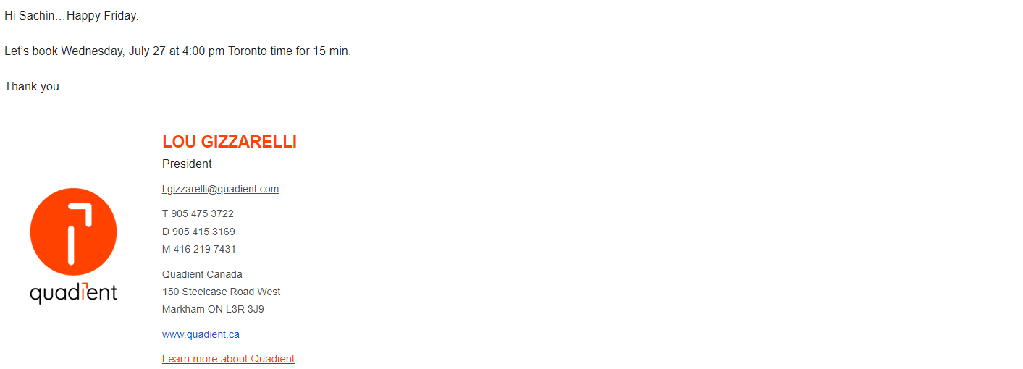

1. Nike – within 20 minutes of sending a cold Email

